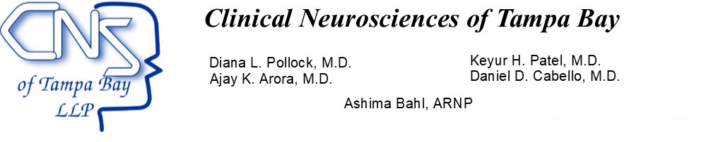
Patient Release of Medical Records
Date:________________________
From CNTB:
I authorize Clinical Neurosciences of Tampa Bay, LLP (CNTB) to release my medical records to:
Fax Number for the requesting Doctor or Facility

____________________________________

Address of requesting Doctor or Facility:
___________________________________________________________________
___________________________________________________________________
___________________________________________________________________

Please note charges may apply for records, if we are releasing to the patient. There will be no charge for fax records to another office. First 5 pages are free and $1.00 per page after up to 25 pages and .25 cents every page after that.

CNTB is authorized to send the following to the above address or fax (check all that apply)
_ Copies of medical records
_ Discharge summary from hospitalization
_ X-ray, CT, MRI, or other Imaging results
_Other

Patient Signature_________________________________________________________________

Patient Printed Name: _____________________________________________________________

Patient Date of Birth: ______________________________________________________________

Witness Signature: ________________________________________________________________

Confidential fax! The personal health information contained in this transmission is highly confidential. It is intended for the exclusive use of the addressee. It is to be used only to aid in providing specific healthcare services to the patient. Any other use is a violation of Federal law (HIPPA) and will be reported as such. If the reader of this message is not the intended recipient, you are hereby notified that any dissemination, distribution, or copy of this communication is strictly prohibited. If you have received this communication in error, please notify our office immediately.

